

Functional Design Document

**Packing Material**

**Joyalukkas India Ltd**

Microsoft Dynamics 365

07-FEB-2022

**Version:01**

**The Process should be tested and practiced in the demonstrated manner only**

Table of Contents

1. Business requirement-Packing Material. 3

2. Solution 4

2.1 Expense booking of packing material at the time of purchase. 4

2.2 Booking sale at invoice level while POS retail sale. 4

3. Risk, Issues, Assumptions, Dependencies 7

4. Setups 8

4.1 Defining item which get expense out while purchasing. 8

4.2 Defining Item group 8

4.3 Defining Item Model group 8

4.4 Configuring New Button on POS for adding packing material on sale line 8

5. Effort Estimate 8

|  |  |
| --- | --- |
| Document Title | Packing Material Tracking in Retail POS Sale |
| Subject | Packing Material Tracking in Retail POS Sale |
| Document Author | Simran Sharma |
| Version | 1.00 |
| Project | Joyalukkas |
| Project / Project Manager | Raj Bahadur |
| Project Phase | D365 Support |
| Approver (Level-1) | Sakshi Sehgal |
| Approver (Level-2) | Raj Bahadur |
| Preparation Date |  |
| Addressed to | Mr. Linson |

**Version History**

|  |  |  |
| --- | --- | --- |
| **Version** | **Dated** | **Remark** |
| 1.00 | 07-Feb-2022 |  |

# Business requirement-Packing Material.

* JA want to expense out the purchase of packing material immediately at the time of purchasing
* Keep a track of packing material issued to customer in each invoice. To do so user wish to add a packing material to each sale and then generate the invoice.
* A report is required where user will see invoice wise packing material issues to customer.
* On print of invoice packing material should not be printed.

# Solution

## Expense booking of packing material at the time of purchase.

## Booking sale at invoice level while POS retail sale.

A separate retail hierarchy node as Packing material to be created. This is done to differentiate it from jewellery item, and exclude it from zero validation on sale line.

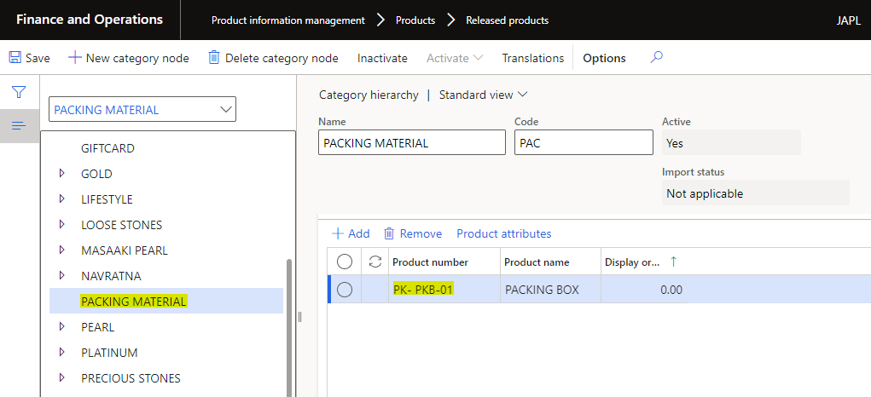

Process Assortment and Sync the item master to POS.

Creation of estimate and till finalise steps remain the same, once sales line comes to main screen (Cashier screen) of POS, user will have option to add packing material.

User can select the required packing material which will be added to sales lines with zero value.

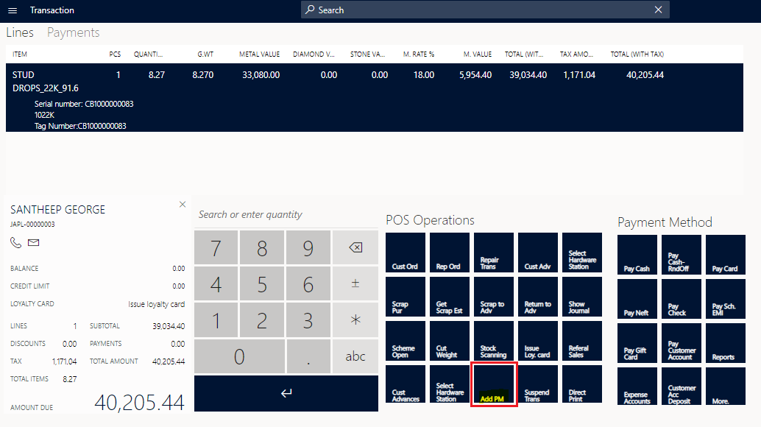

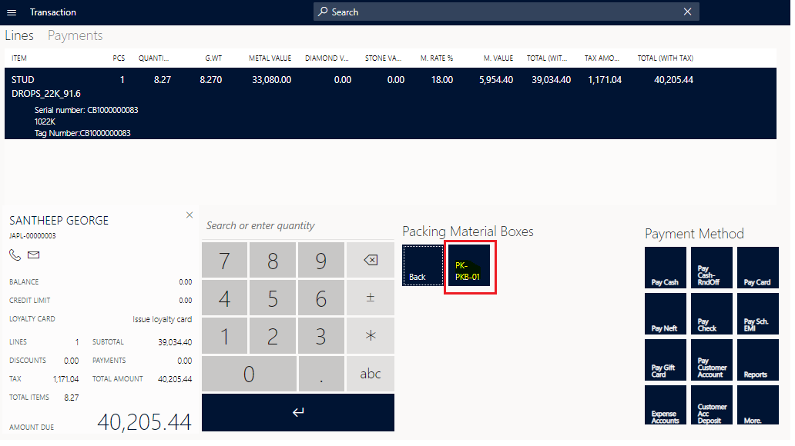

On clicking of respective packing material system will add one packing material line in sales line. currently X rs is defined as there is a validation in system, for not billing any zero-value line.

User can define 1 rs for packing material value and give 100 percent discount in it (Setup explained in Setup section)

This zero-price validation will be made specific to category / Item

Image of packing material can also be configured on button explained in setup section.

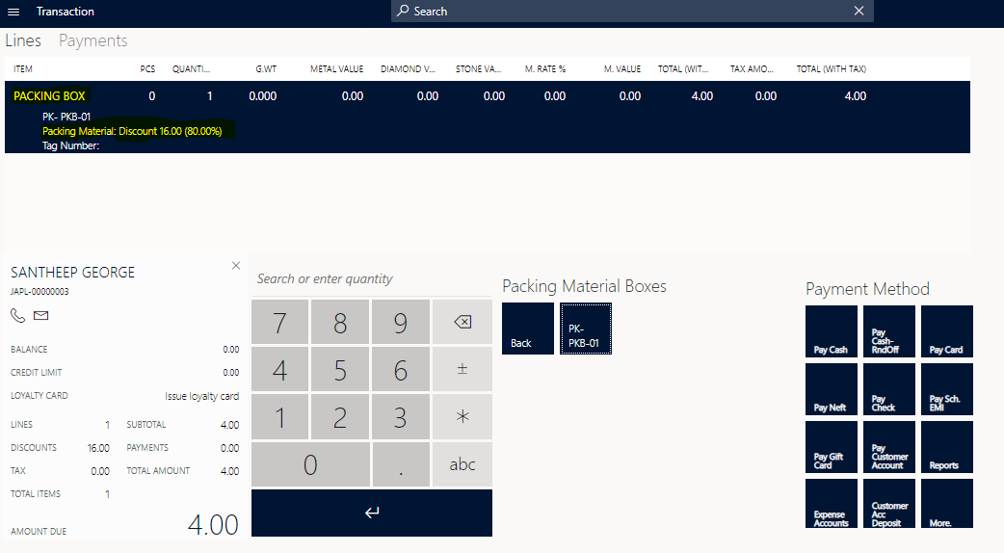

User can do this operation any number of times i.e. more than one no’s or more then one type of packing item can be added in one sale bill.

After this user can bill the invoice as regular process.

Invoice Print

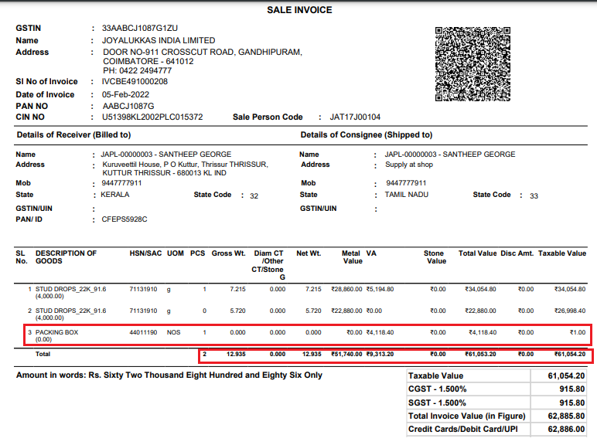

Item belonging to packing material category need to be excluded from printing.

Logic of driving total should exclude the item belonging to packing material category. This will be hard coded in system.

# Risk, Issues, Assumptions, Dependencies

1. As it is standard POS functionality, it does not check inventory on hand and allow POS sale. If packing material inventory is not there in system POS will not stop whereas it will not allow day end posting for complete invoice.
2. While sales return if packing material does not come back and user don’t return it, then invoice will remain standing in system.
3. The validation that packing material must be added in sales bill is not feasible, as EMI, advances are all sales entry then system will force to add packing material there too.
4. This change is only for POS retail sale.
5. Any change due to this change will be new CR request.
6. Any change in SMS, Email, Report, print (Except POS invoice print) due this change will be separate CR.
7. Scenario creation to be done by JA team.
8. Production deployment will only be done after written UAT signoff.
9. Any scenario which is not forecasted and written in this document resulting to failure of solution will be separate CR.
10. Approval to this document will be understood as complete approval of CR along with effort.
11. Approval of document means that JA team has understood the document clearly and completely and change which is going to happen in system are accepted by them.
12. Anything which is not mentioned in the document is out of scope and nothing is self-understood or presumed.
13. Once the solution is approved report section and effort will be added to this document.

# Setups

## Defining item which get expense out while purchasing.

To be added

## Defining Item group

As per Standard D365 setup

## Defining Item Model group

As per Standard D365 setup

## Configuring New Button on POS for adding packing material on sale line

Screen layout:

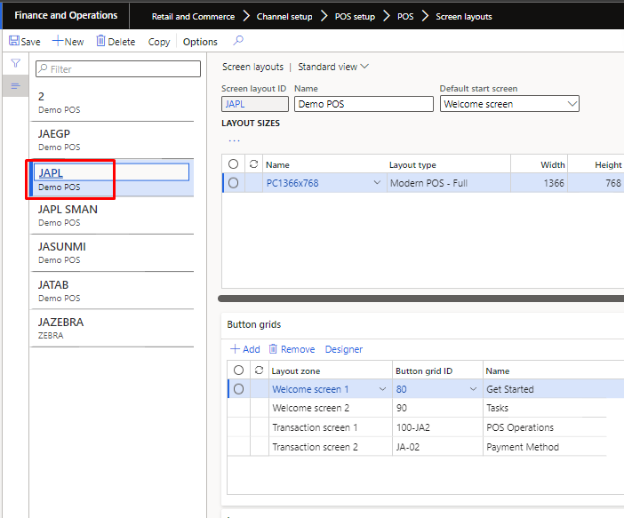

Addition of new button grids:

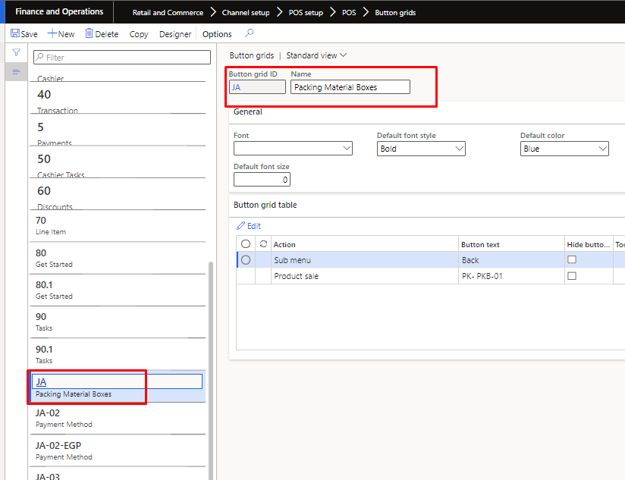

Open the designer of Button grids defined in screen layout.:

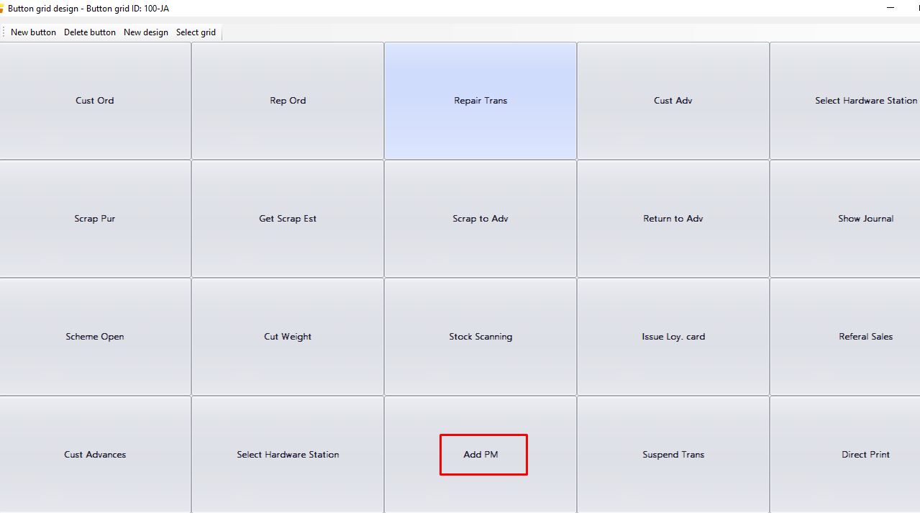

Open Button properties:

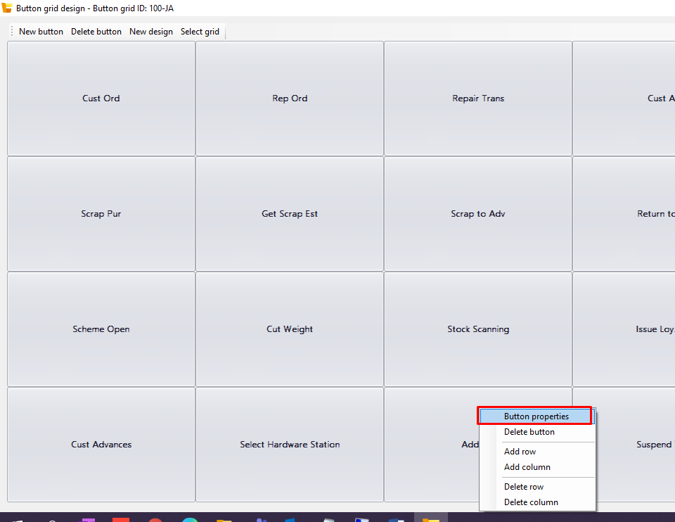

Add Sub Menu in section and in menu- select new button grid that user created above.

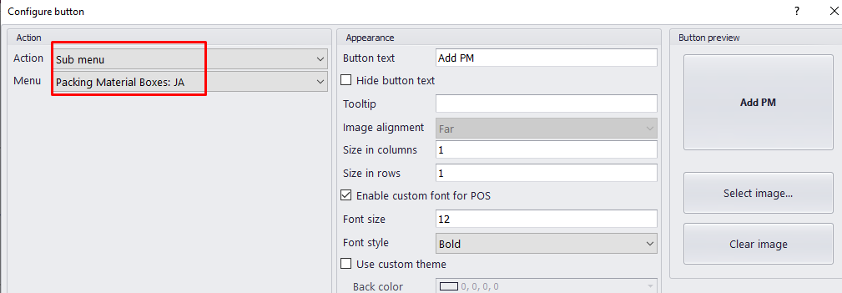

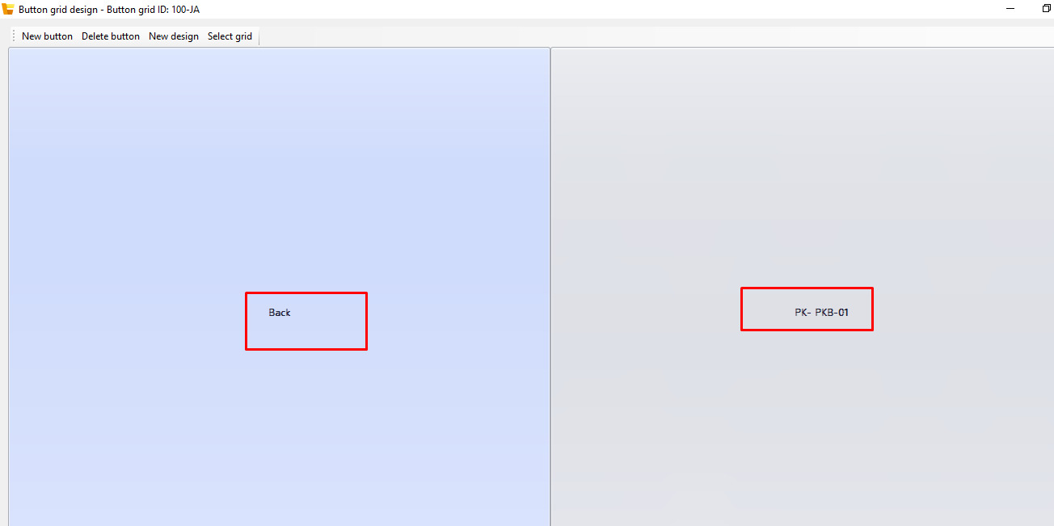

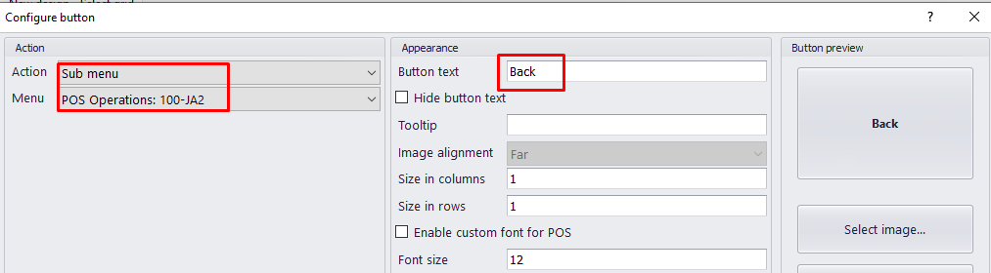

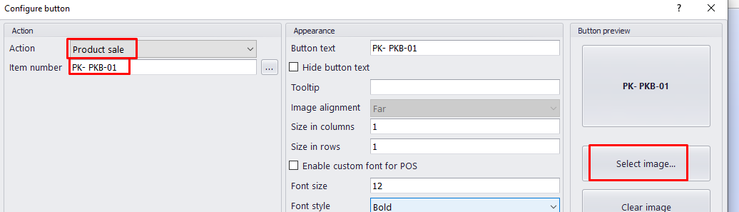

## Adding image in POS button

After creating Buttons, run Batch Job-‘1090’ under distribution schedule

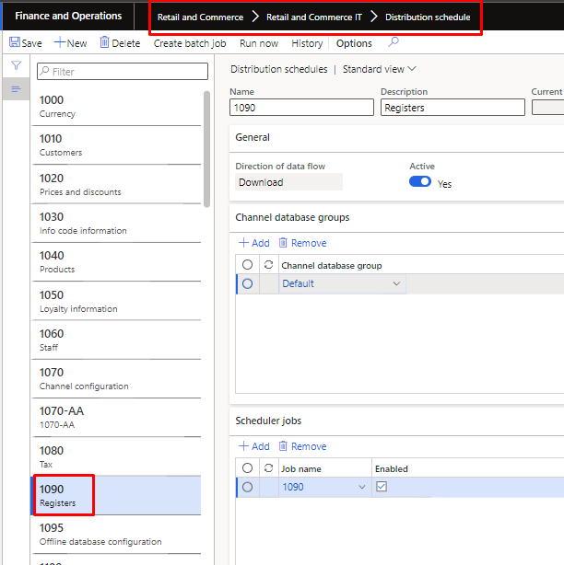

## Defining sale price of item and discount

1. Defining Base price in Item Master.

Product Information Management>>Released Product

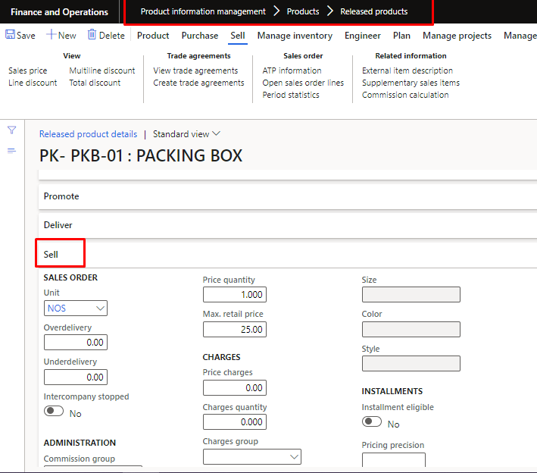

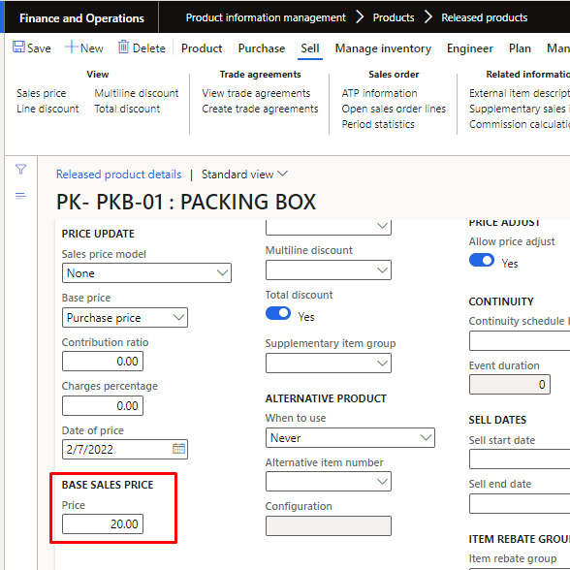

1. Discounts setup

Path: Retail & Commerce>Pricing and discounts>All Discounts

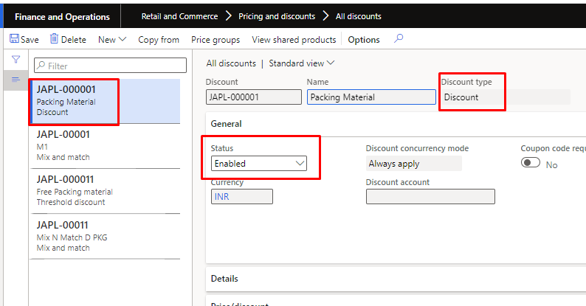

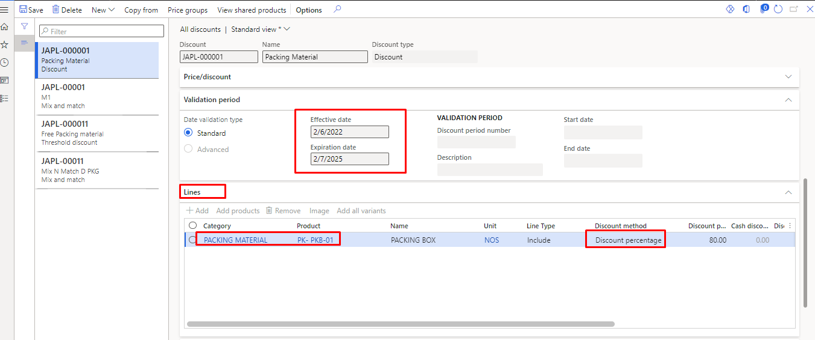

In line section item on which discount is required to be added.

Defining Price Group and Channel in Discount master (It define the stores on which this discount is applicable.)

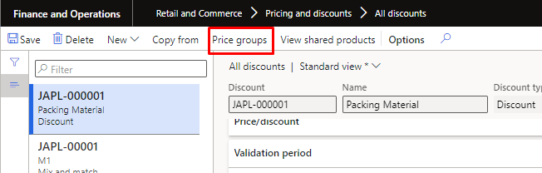

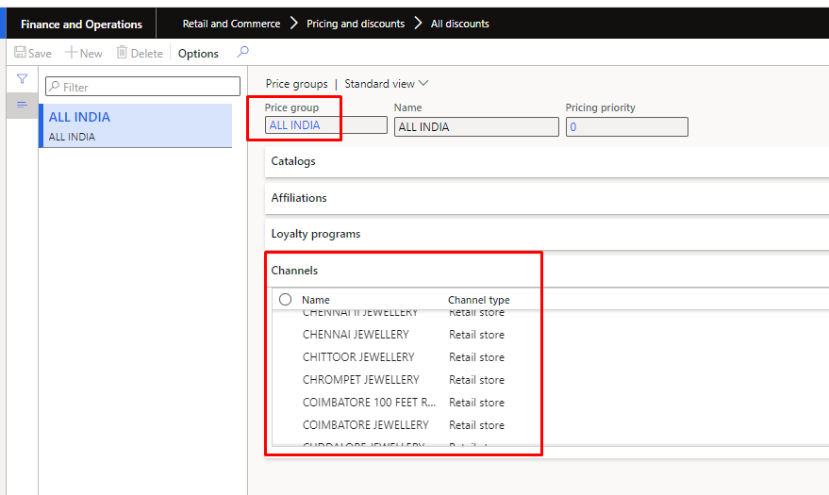

Run ‘1020’ Batch Job in Distribution Channel to sync the data from D365 to POS.

# Effort Estimate

|  |  |
| --- | --- |
| Analysis & Documentation |  |
| Development (Excluding Report) |  |
| Testing, UAT, Deployment |  |
| **Total** |  |
| Contingency (Over and above total if any unforeseen situation arises else will not be used) |  |